Accessing Oliver, using the library and accessing other libraries – Information sheet for Year 12s
- It is best to search for a resource (book, dvd and so on) on the online catalogue beside the colour printer rather than just go hunting for it.
- To find a resource type your search terms into the search bar and press go.
- A result list will come up. Click on the one you want. 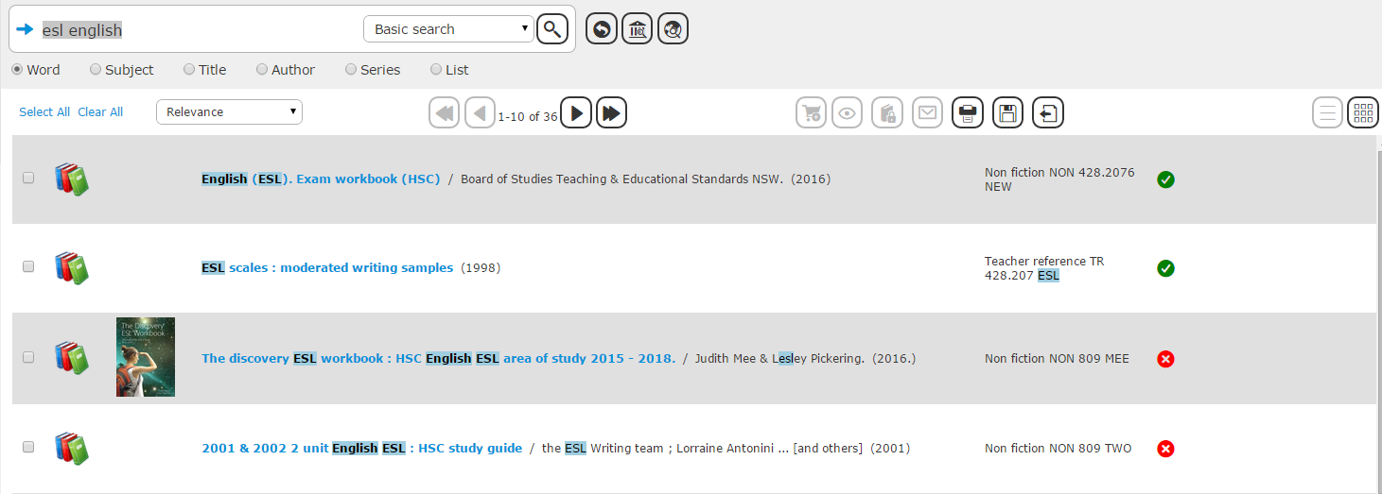
- A cross on the right hand side means that it is out. This tells you where to find the resource on the shelves. So that you don’t forget, you should write this down on a little piece of paper (there is paper and pens beside the circulation computer) and then go find the resource. If you can’t find it, it may be that another student has not put it back in the right place.

- Even if the teacher librarian orders in a resource for you this can take weeks to come in. So, in the mean-time why not try to get it from another library. To do this, put in your search term but instead of clicking go click on this icon.

- Then choose the library that is nearest to you. 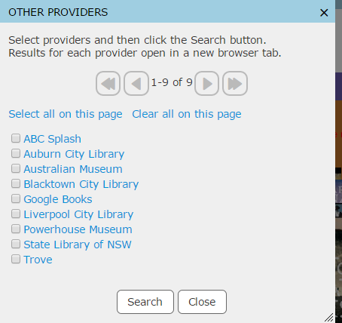

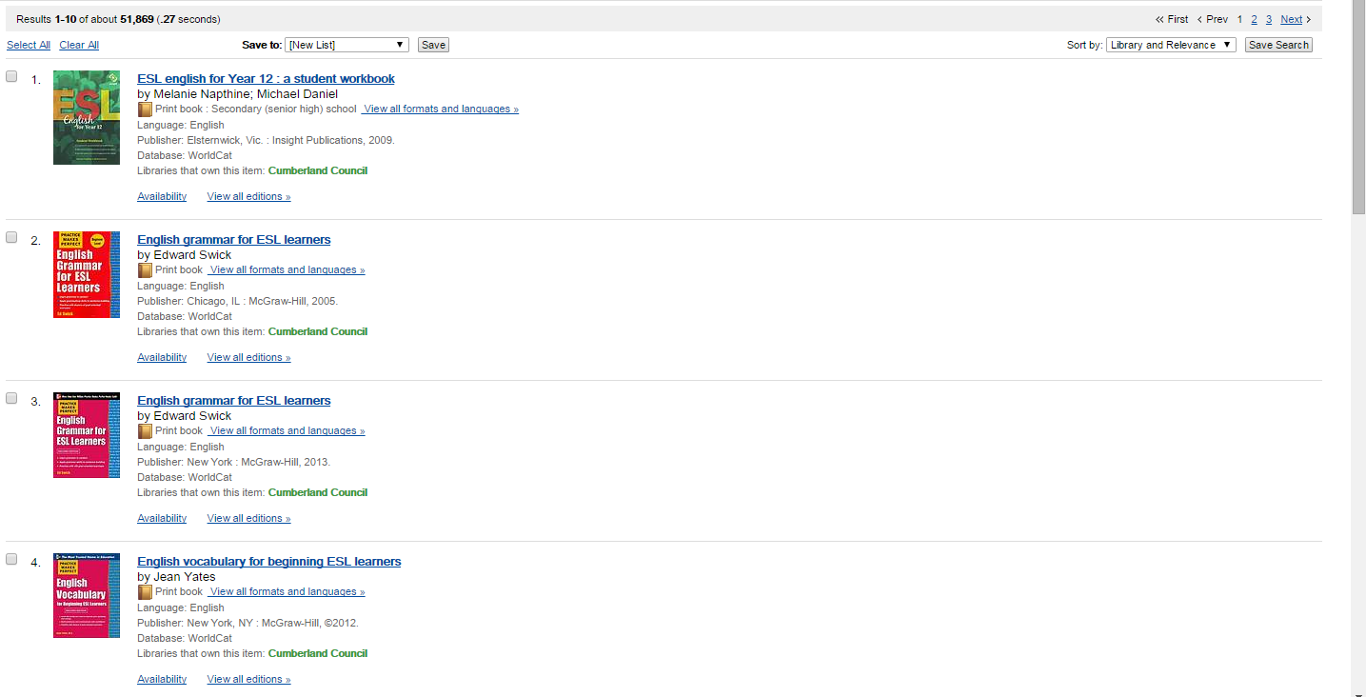
This is the Auburn library catalogue result list. As you can see on the other providers window you can also access the state library of NSW website there too and the National library of Australian Website (Trove).

- To access the State Library of NSW website type SLNSW into Google. Then open the google search result for the NSW state library.
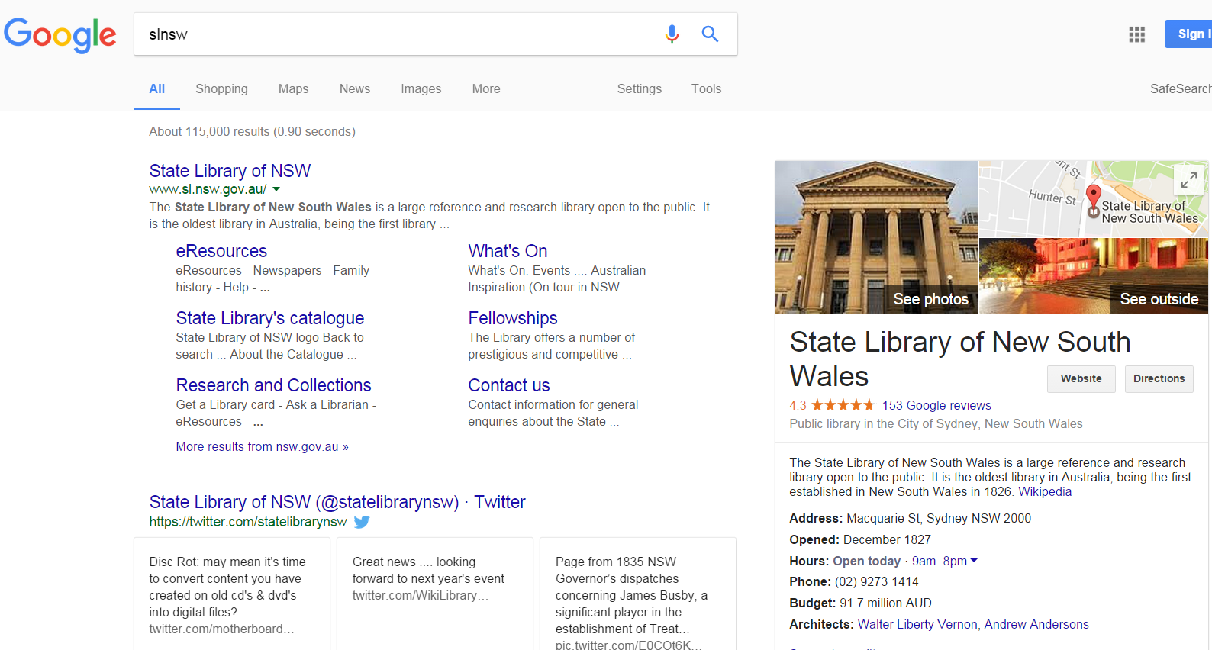

Click here

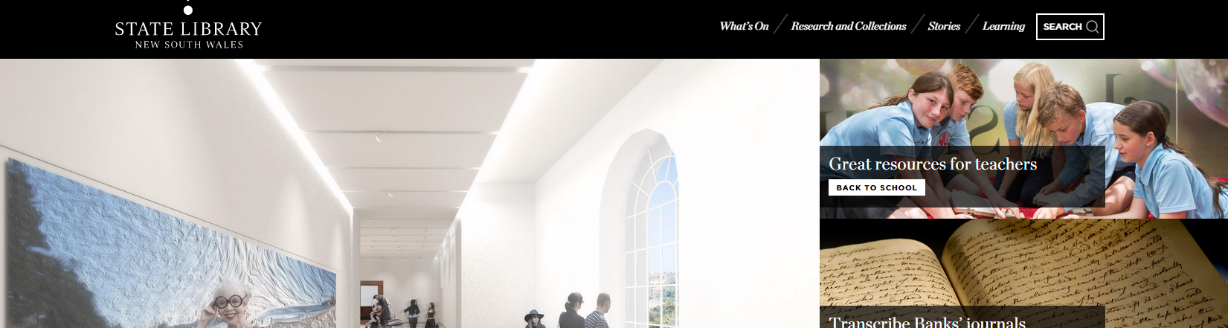

- To access the State Library databases and the Sydney Morning Herald online go here. 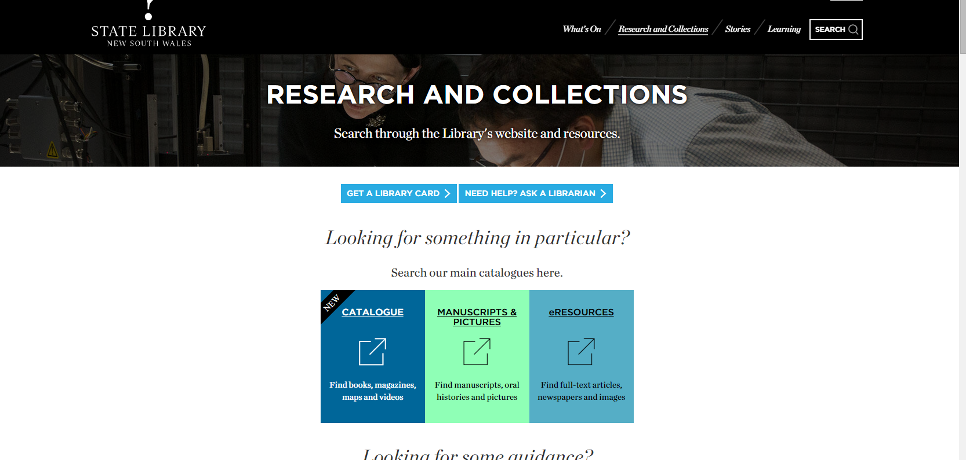

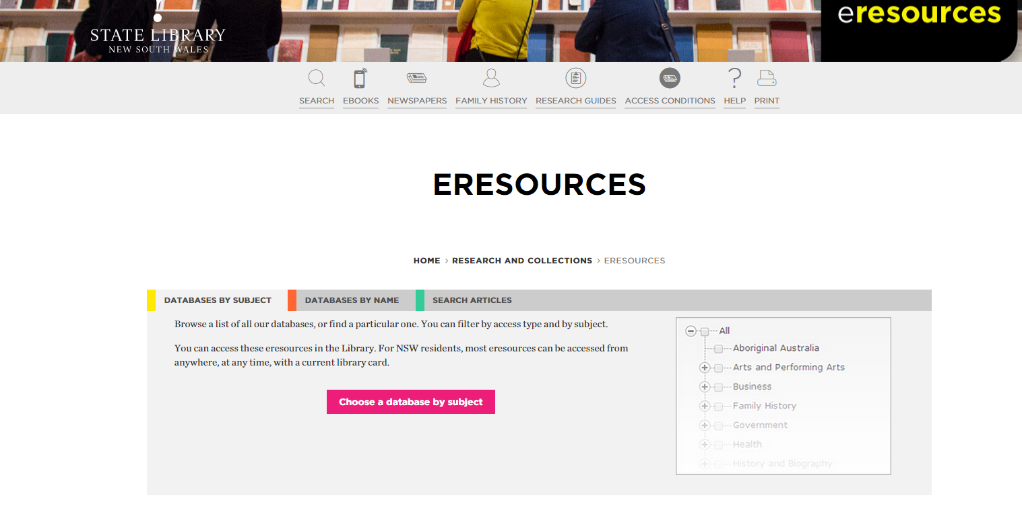

Click here and put in SMH.

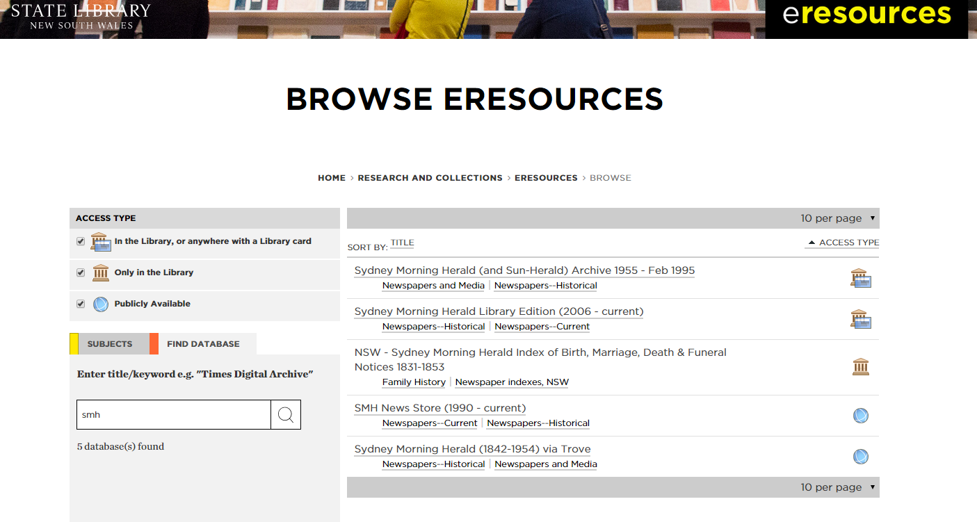

Double click here to go to the SMH. You will need a library card for the next step but this is quick and easy to do.

- To get a state library card, click here

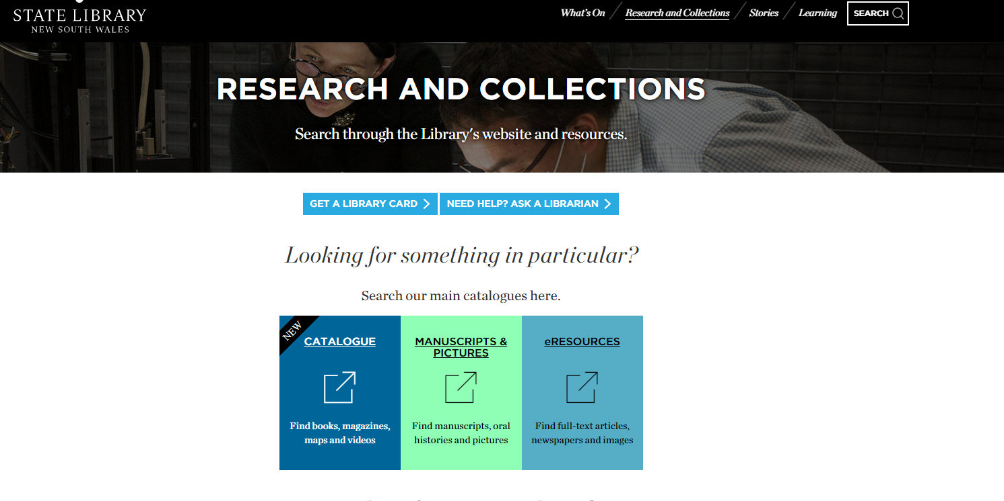

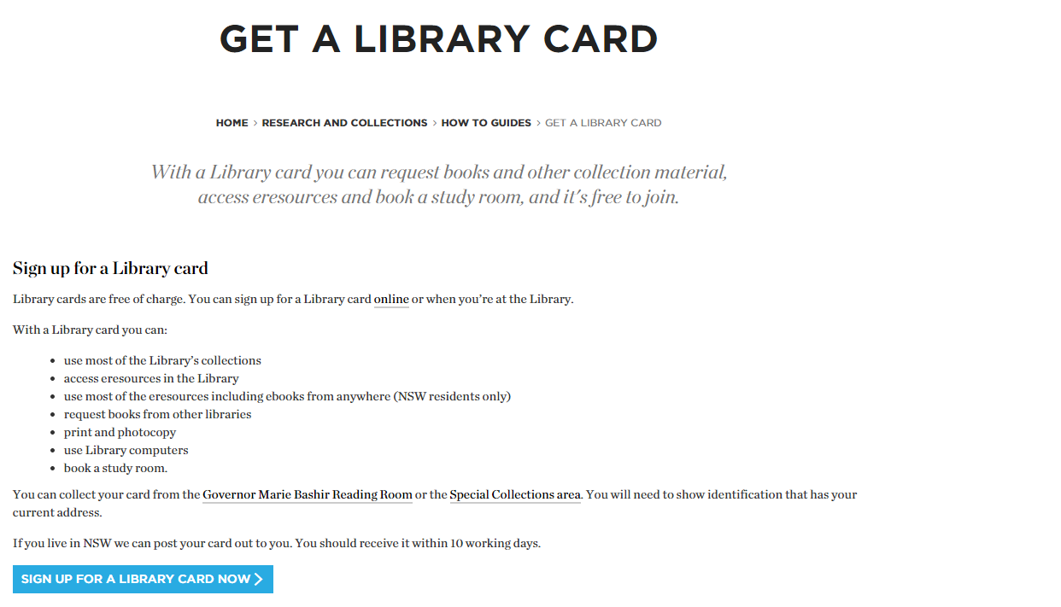

Click here. You can sign up over the phone or online. You can choose to pick up your card yourself or they will mail it to you.

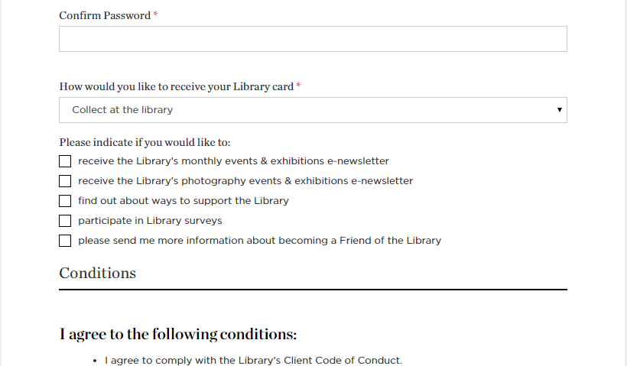

Select the arrow to change the option.

- The truly great thing about the new Oliver library catalogue is that you can access it 24/7 where-ever you are. You can even access the catalogue on your phone if you have wifi. To do this:
- Go to your student portal and click on this icon.

