Reservations and Orbit

Reservations
- In the search bar, put in a search term such as Art and hit enter or the little magnifying glass beside the bar.

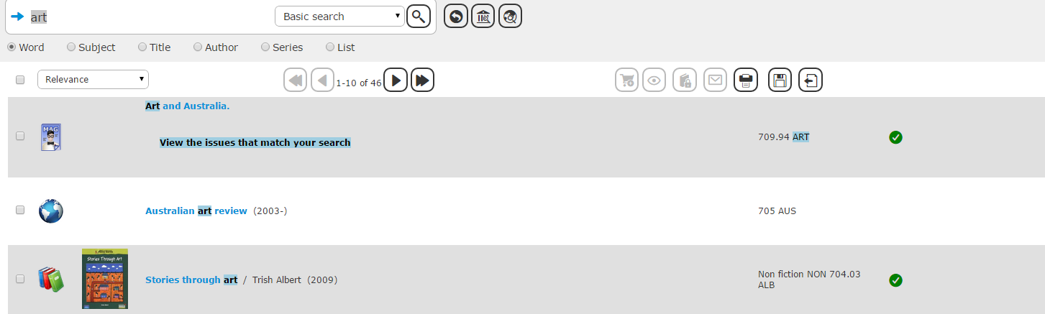

- Choose a resource such as stories through art and click on the icon on the right that has a book and padlock in it.
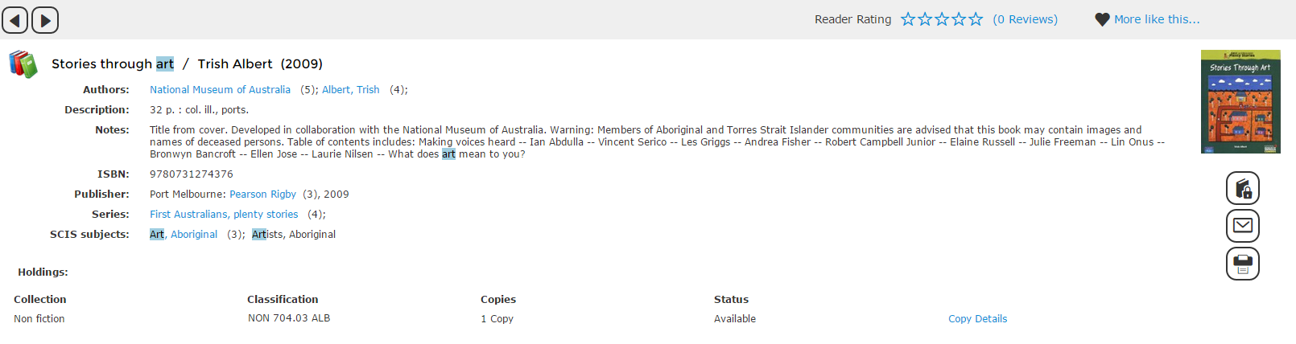

- Click on the floppy disk icon and leave as first available.
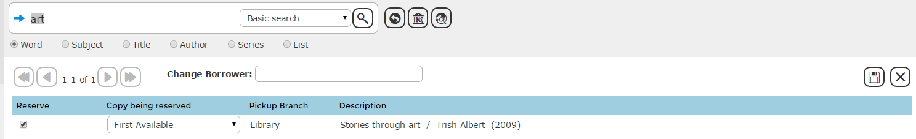

- You will see in reservations that you have a reservation and you can click on this.
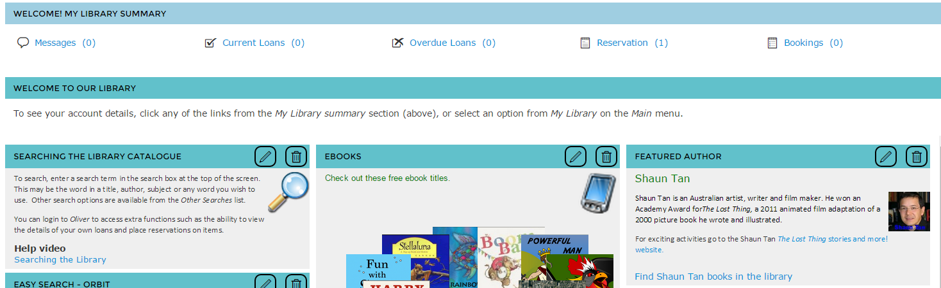

- When the copy comes in you will see a notice saying to come and pick up the resource and it will be on the little wooden trolley next to the photocopier outside the TL’s office. You will also get an email. The resource will have a little jacket on it with your name on it. Reservations by a number of borrowers will indicate that there might a high demand for a particular copy and that the library should consider acquiring another one.
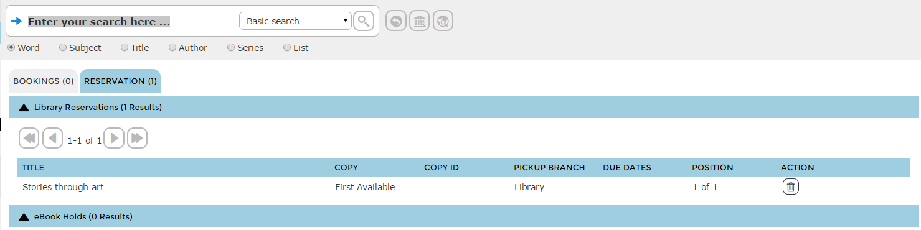

Orbit
Orbit is an alternative interface that is better suited to students with lower language abilities (eg. IEC, EFS and so on), especially because it is more visual. I prefer to use this on occasion.

- To Access Orbit click on the space icon in the top right corner.
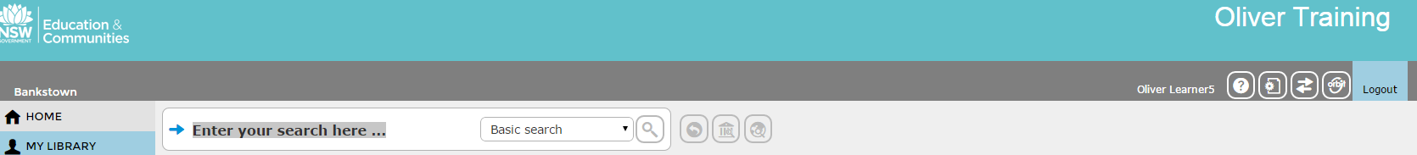

- You can do pick and click to drill down to what you want or just search by clicking on the Binoculars.
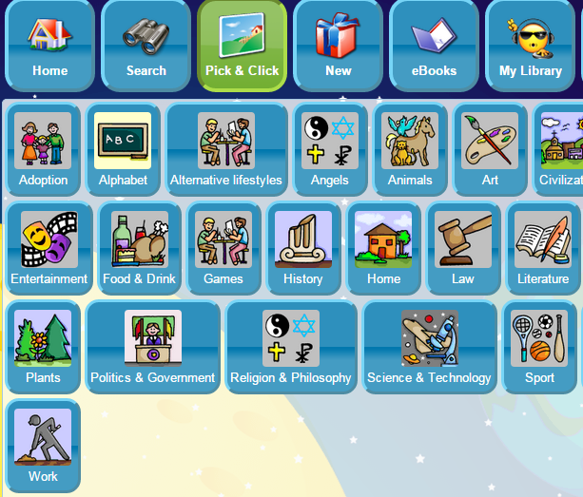

- You can look at e-books and soon you will be able to borrow them.
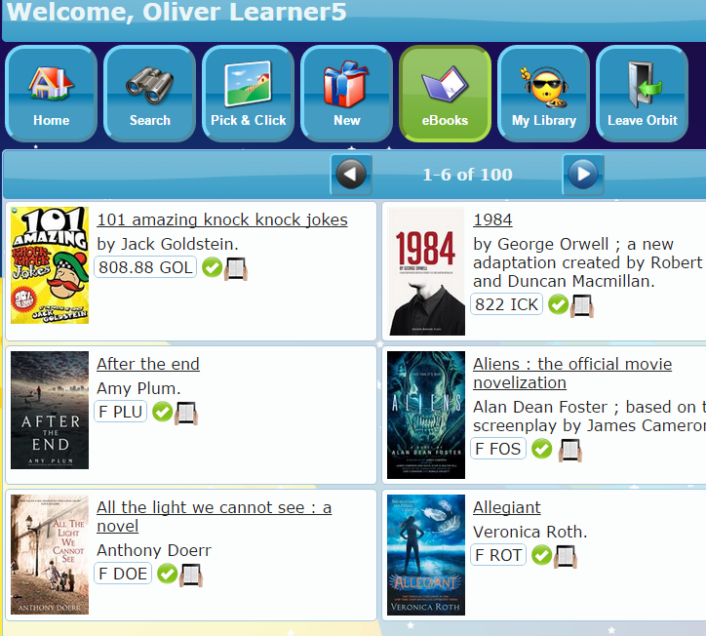

- In settings, in My Library you can see your borrower information and change the look of your pages.
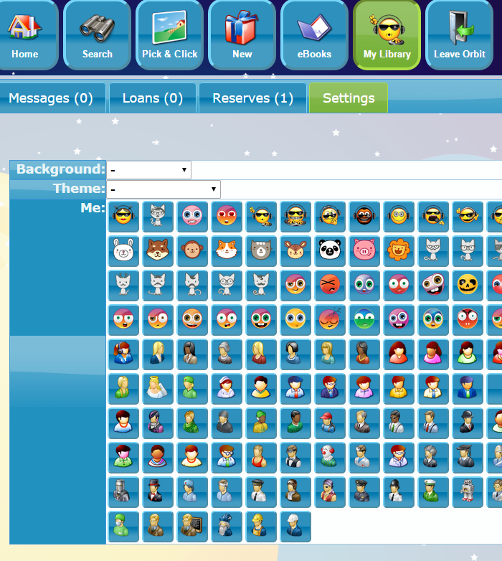

Click on Background, Theme and me to change these and click save.
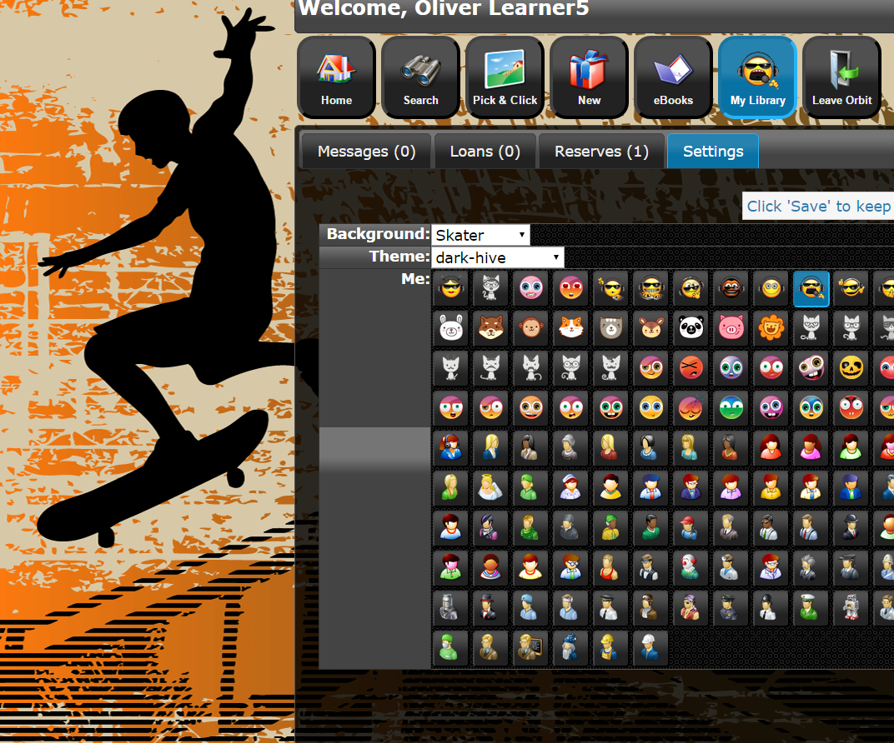

Please Note: With Build 8 the problem of not being able to get out of orbit has been fixed with the Leave Orbit icon above.

