Accessing BSC’s new Fitzroy Readers collection

To access Fitzroy readers and the wealth of literacy activities and phonics that go with them here’s what to do.
- Go to the start menu and start typing Fitzroy. The readers 21-30, 31-40, and 41-50 will come up.
Click on whichever. Please note: the readers get longer and more challenging as one progresses up through the numbers. The individual readers focus on various language features, grammar and sentence structures.

Compare Book 21
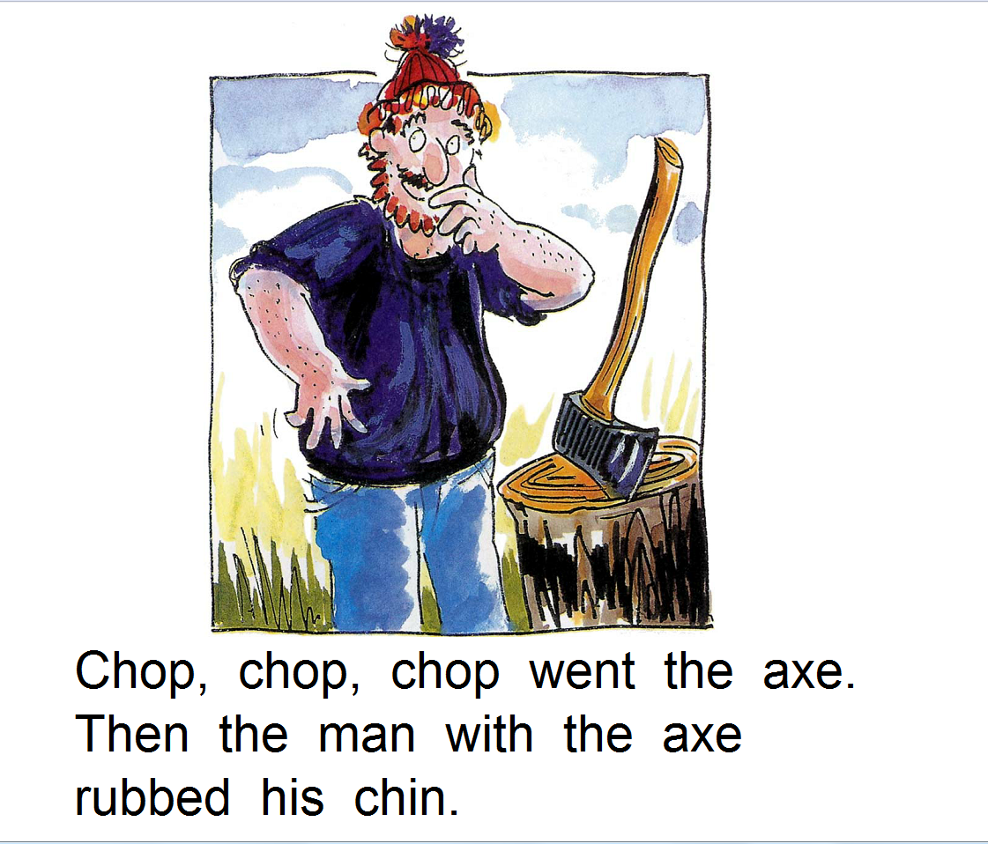

With Book 45
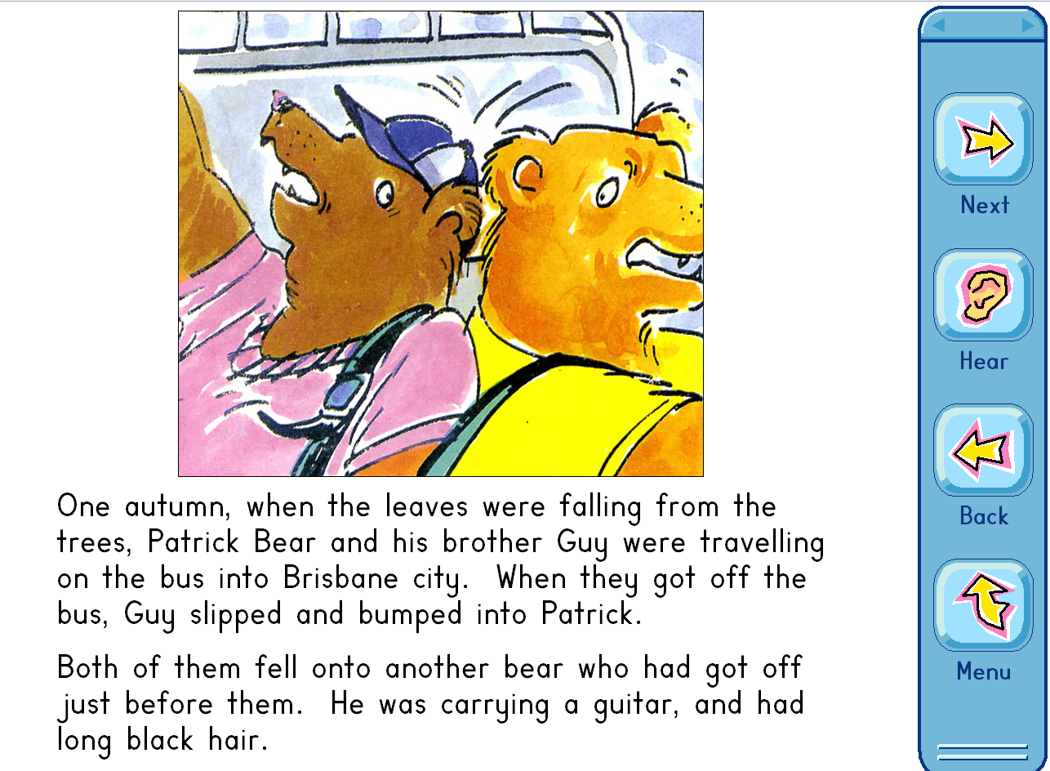

BSC’s site licence allows us to access the readers only at school. To try to access them at home using a school PC, for instance, would be in breach of our licence.

About Fitzroy readers
You can read all about Fitzroy readers here http://www.fitzprog.com.au/ . As the website says, there have been over 2 million books sold.

Many will be familiar with Fitzroy readers in print but it is possible to now get them as a site licence to put on PCs in a school, for instance, or get them through the app store for iPad.

The basic or primary difference between print and electronic is that one can now hear the text read out, read along with the narrator, follow the text using an underline and hear individual vowel and consonant sounds in words.

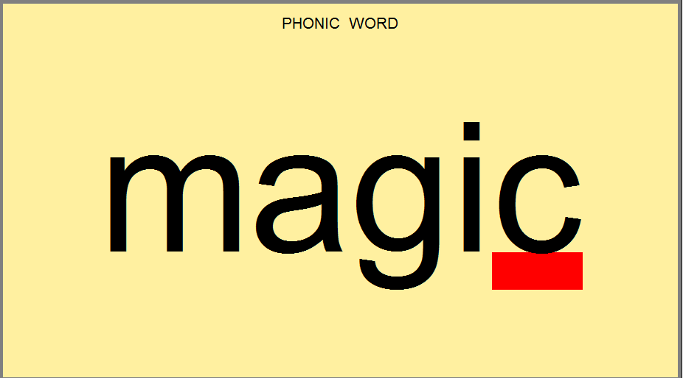

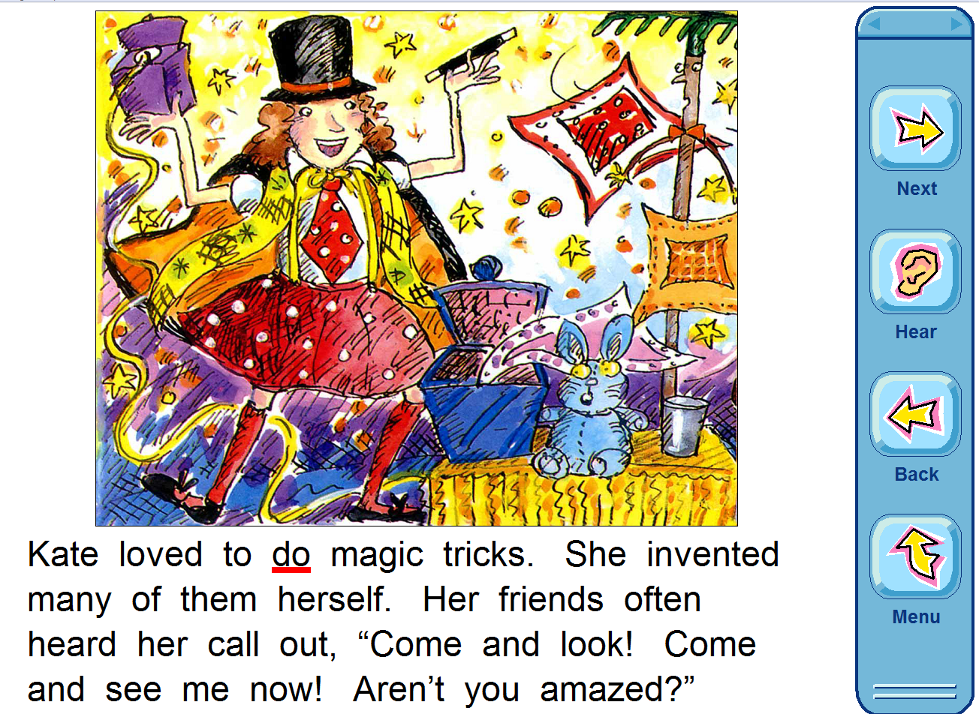

About the teacher resources and activities that go alone with Fitzroy readers.
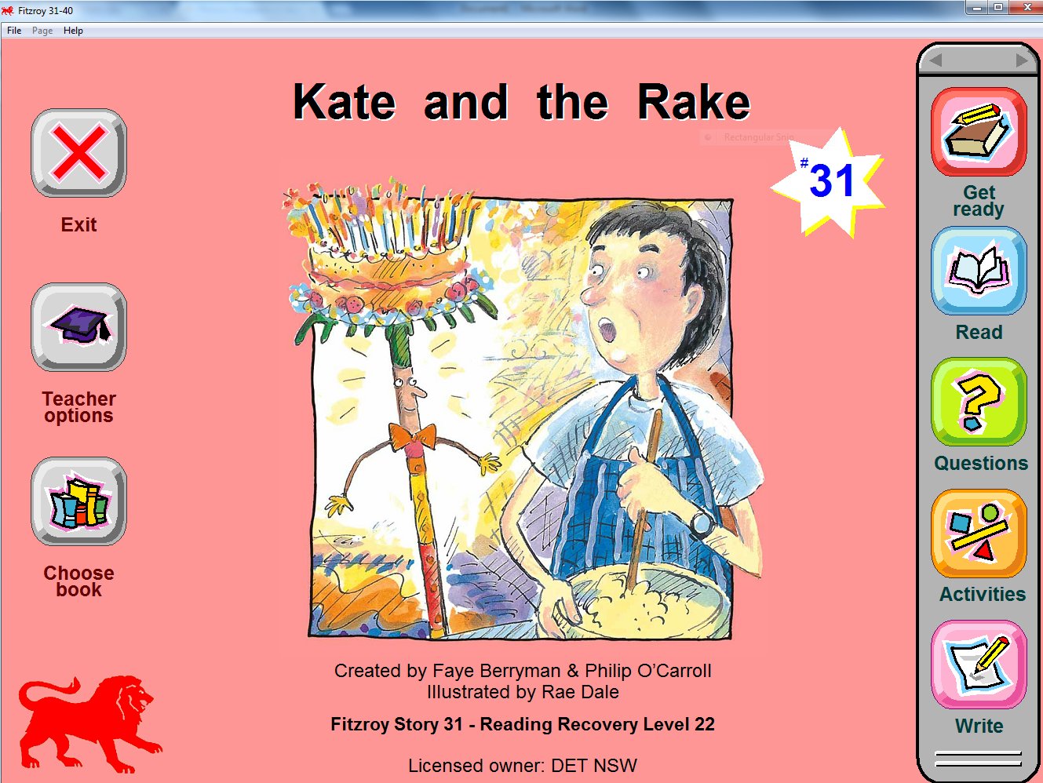

There are so many awesome activities. Here are two.

- Questions. For example:
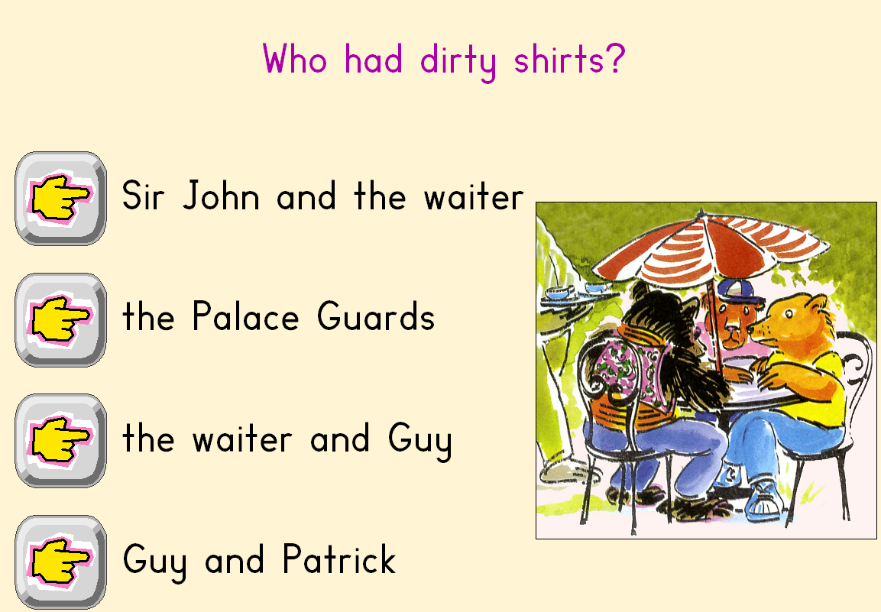

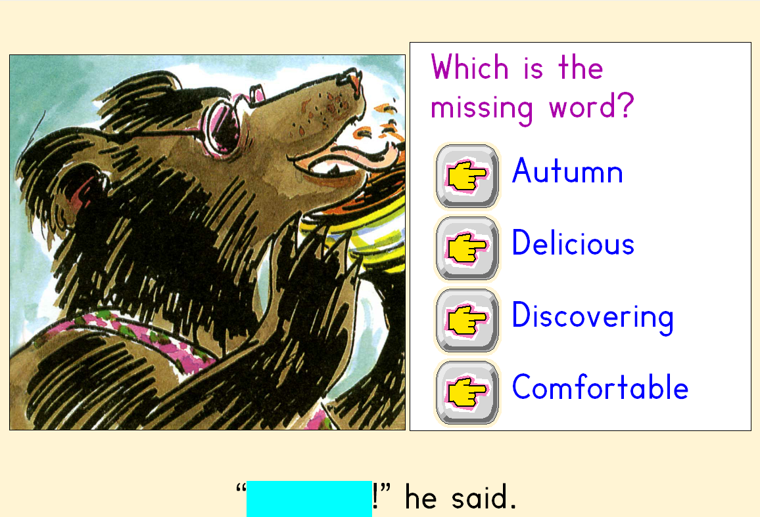

- Activities. For example:
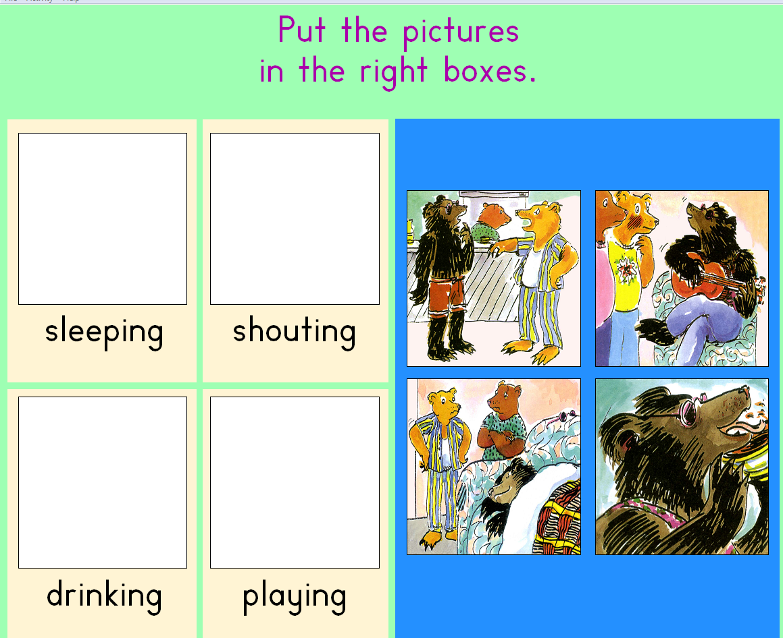

One I really love is Write.

You can create your own story and give it a title. I created that title
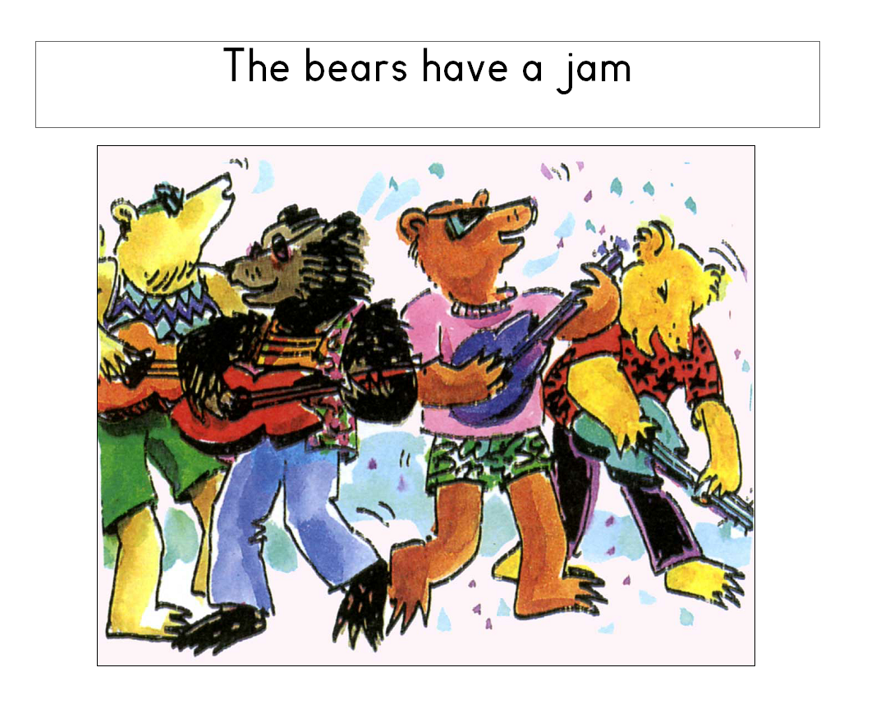

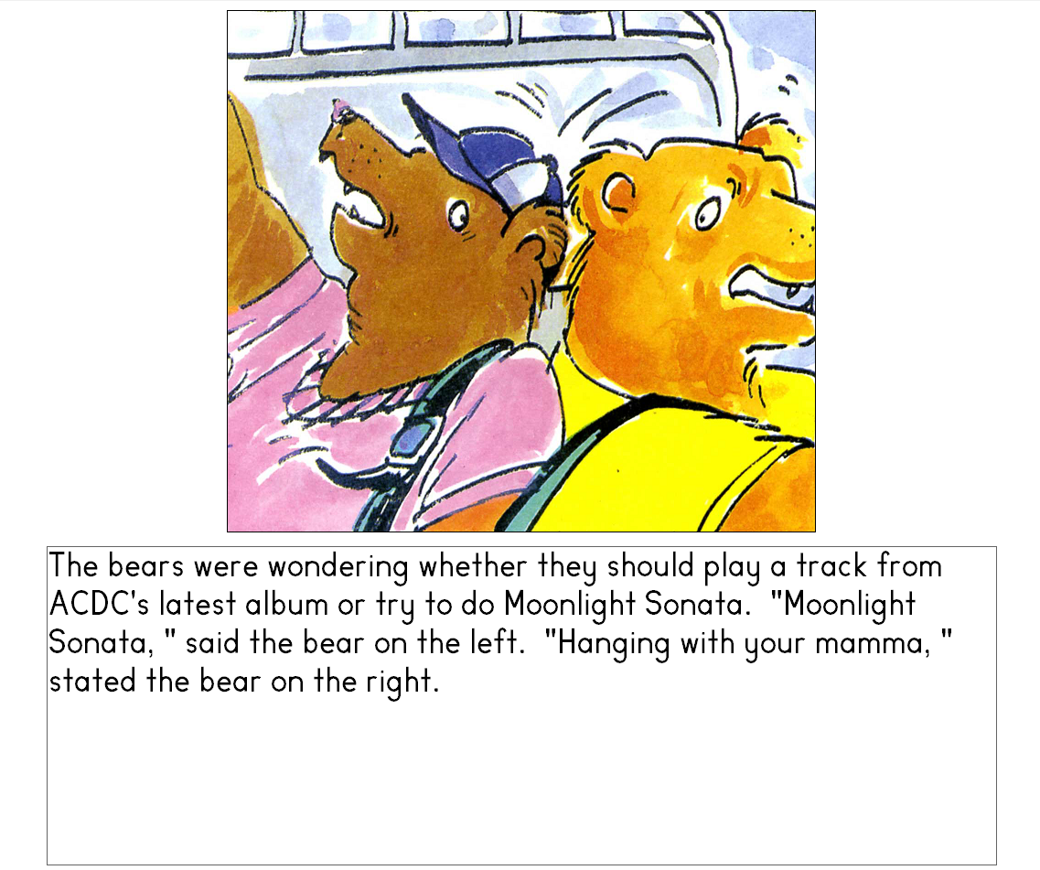
I wrote this text as corny as it is.

Then you can click hear and hear your text read out.

